Deep Learning Approaches in the Diagnosis and Progression Tracking of COPD: A Comprehensive Review

Lalit Verma  School of Computer Science and Engineering  Lovely Professional University  Phagwara, Punjab, India  lalit.verma2713@gmail.com  Shivani Sharma  School of Computer Science and Engineering  Lovely Professional University  Phagwara, Punjab, India  Shivani.29443@lpu.co.in | Kanad Kapil  School of Computer Science and Engineering  Lovely Professional University  Phagwara, Punjab, India  kanadkapil7@gmail.com  Siya Thakur  School of AI and Emerging Technologies  Lovely Professional University  Phagwara, Punjab, India  Siyathakur8847@gmail.com

Abstract
Chronic Obstructive Pulmonary Disease (COPD) stands as the third leading cause of death worldwide, yet standard spirometry-based diagnosis remains inadequate for capturing early structural damage or reliably anticipating disease worsening. This review surveys the peer-reviewed literature on deep learning and machine learning applications across three complementary clinical data streams: convolutional neural networks (CNNs) applied to pulmonary CT imaging, recurrent sequence models applied to respiratory audio and intensive care unit (ICU) physiological data, and ensemble classifiers applied to structured electronic health records (EHRs). The principal benchmark datasets examined are COPDGene, MIMIC-III, and the ICBHI Respiratory Sound Database. The review further covers the growing body of work on multimodal fusion architectures that combine imaging, acoustic, and tabular inputs within a unified framework, and identifies the key obstacles — dataset diversity, model transparency, and edge deployment — that must be addressed before these systems can move from research settings into routine clinical use.
Keywords—Chronic Obstructive Pulmonary Disease; deep learning; convolutional neural networks; long short-term memory; electronic health records; multimodal fusion; clinical decision support.

I. INTRODUCTION

Chronic Obstructive Pulmonary Disease (COPD) is a chronic inflammatory airway condition marked by persistent, progressive airflow limitation caused primarily by prolonged exposure to inhaled irritants, most commonly tobacco smoke [1]. Its clinical presentation spans a broad continuum, from mild obstructive bronchiolitis to severe emphysema with respiratory failure, and individual trajectories vary considerably even among patients with comparable exposure histories [1]. The cumulative global toll is substantial: COPD is the third leading cause of mortality worldwide and places a rising economic burden on health systems at every income level [5].
Diagnosis and disease staging have long followed the framework of the Global Initiative for Chronic Obstructive Lung Disease (GOLD), which classifies obstruction severity using the post-bronchodilator forced expiratory volume in one second to forced vital capacity ratio (FEV₁/FVC < 0.70) [1]. Spirometry is reproducible and widely standardized, but its reliance on a single expiratory manoeuvre means it captures virtually nothing about the spatial pattern of parenchymal damage that may have been accumulating for years [2]. This structural blind spot drives a well-recognized cycle of underdiagnosis: patients remain undetected until FEV₁ loss is already clinically significant, by which point the window for disease-modifying intervention has narrowed considerably. Spirometry also provides limited forewarning of Acute Exacerbations of COPD (AECOPD) — sudden episodes of symptom deterioration that hasten irreversible lung function decline and account for a disproportionate share of COPD-related hospitalizations and deaths [5].
Artificial intelligence (AI) methods, and deep learning in particular, are beginning to address these gaps. Because they can identify non-linear, high-dimensional patterns across heterogeneous data types that conventional statistics cannot handle, they open new diagnostic and prognostic channels that operate in parallel with, rather than as replacements for, clinical judgment [1]. Work by Yin and colleagues illustrates the point: a deep learning framework grounded in fractional dynamics achieved COPD stage classification accuracy that conventional spirometric indices could not match, suggesting that physiological time-series contain latent structure the standard FEV₁-based staging system fails to capture [4]. Broader AI applications in COPD now span genetic risk scoring, sub-millimeter CT phenotyping, and real-time exacerbation forecasting from wearable sensor streams [6].
This review surveys the published literature on these developments. Source papers were identified through systematic searches of IEEE Xplore, PubMed, and Google Scholar using the query terms “deep learning COPD diagnosis,” “CNN computed tomography COPD,” “LSTM respiratory sounds,” and “electronic health records COPD prediction.” Papers published between 2015 and 2025 were prioritized; foundational dataset and methodology papers were included regardless of publication year. Section II covers CNN-based CT imaging and radiomics. Section III examines recurrent architectures for respiratory audio and ICU physiological streams. Section IV addresses EHR-based predictive analytics. Section V surveys multimodal fusion frameworks. Section VI identifies the principal obstacles to clinical translation, and Section VII draws conclusions.

II. DEEP LEARNING FOR PULMONARY IMAGING

A. From Manual Radiomics to End-to-End CNN Learning
High-resolution computed tomography (HRCT) offers the most spatially detailed view of COPD-related structural changes available without invasive sampling. Conventional radiomics workflows require radiologists to manually delineate regions of interest and quantify features such as emphysema percentage, airway wall thickness, and air-trapping extent — a process that is time-consuming, subject to inter-rater variability, and fundamentally constrained by the features that humans choose to measure. CNNs trained directly on voxel intensities bypass this bottleneck by learning discriminative spatial representations from labeled data without any predefined feature set [10].
The Fleischner Society's position statement established a principled CT-based taxonomy of COPD phenotypes, distinguishing airway-predominant, emphysema-predominant, and mixed subtypes [9]. This classification has since been operationalized computationally: CNN models trained on multi-center CT cohorts can now assign phenotypic labels with accuracy approaching that of subspecialty-trained radiologists, while processing a complete CT volume in a matter of seconds [9]. The shift from manual feature extraction to learned representation carries two practical advantages. First, CNNs are not limited to features that clinicians already know to be important; they may surface image signatures that have no established radiological name but carry genuine prognostic weight. Second, learned features scale without additional annotation effort once a model is trained.
Chen and colleagues demonstrated this potential using the COPDGene longitudinal cohort [10]. Their CNN extracted latent CT representations, designated Image-Expression Axes (IEAs), that correlated with systemic inflammatory gene expression profiles. This cross-modal association implies that structural lung changes visible to a trained network encode biological information beyond what spirometric summary statistics reflect, opening pathways for imaging-guided molecular stratification of COPD patients.
B. Dual-Phase CT and the Expiratory Imaging Advantage
COPD is at its core a disease of expiratory flow limitation. Standard single-phase inspiratory CT visualizes emphysematous destruction reasonably well but is largely blind to dynamic air trapping and airway collapse on exhalation — the phenomena that most directly reflect obstructive physiology. Dual-phase protocols, which acquire both inspiratory and expiratory scans during the same session, directly image these dynamic features [12].
Zhang and colleagues trained a CNN on dual-phase CT data combined with structured clinical metadata from a multi-institutional cohort [12]. The internal validation results showed that expiratory CT alone (AUC 0.897) outperformed inspiratory CT alone (AUC 0.888), consistent with the physiological argument above. Combining both phases yielded an AUC of 0.912, and adding clinical variables to the imaging embedding pushed performance to 0.930. External validation on an independent cohort produced an AUC of 0.896, confirming that the reported gains were not artefacts of dataset-specific overfitting. Table I places this and related CNN-based studies in a comparative context.

TABLE I

Study | Dataset | Architecture | Key Metric | Finding
Chen et al. [9] | COPDGene (>10,000 subjects) | CNN (IEA extraction) | IEA-gene correlation | CT phenotypes linked to gene expression profiles
Oh et al. [10] | COPDGene (longitudinal) | 3D CNN | C-index 0.71 | DL-quantified emphysema progression predicts 5-year mortality
Zhang et al. [11] | Multi-center dual-phase CT | CNN + clinical fusion | AUC 0.930 | Expiratory CT outperforms inspiratory CT alone
Bodduluri et al. [2] | COPDGene spirometry + CT | Deep neural network | AUC >0.80 (phenotype) | Spirometric waveforms reconstruct CT structural phenotypes without imaging
Representative CNN-Based CT Studies for COPD Diagnosis
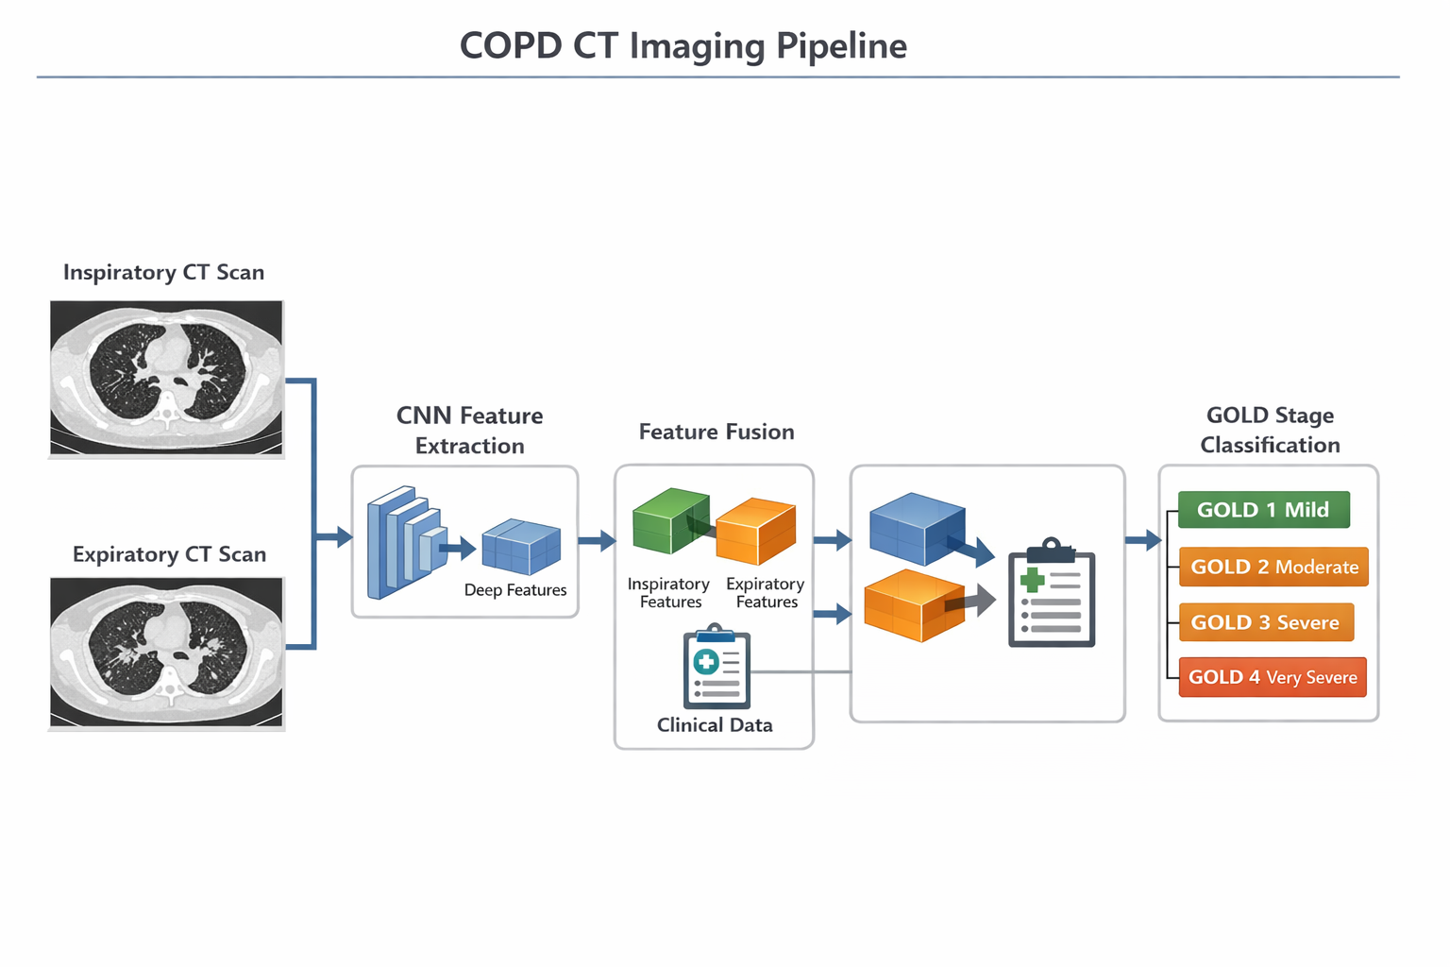
Fig. 1. Proposed schematic of a dual-phase CT deep learning pipeline for COPD phenotyping. Inspiratory and expiratory volumes are processed by parallel CNN branches; embeddings are concatenated with clinical metadata and passed to a GOLD-stage classifier. (Authors’ original illustration.)

C. Longitudinal Progression Modeling
Perhaps the most clinically consequential application of CT-based deep learning is the longitudinal tracking of disease progression. Oh and colleagues showed that a deep learning model applied to serial COPDGene CT examinations could quantify emphysema progression at a sensitivity substantially exceeding that of radiologists relying on standard visual scoring scales [11]. More importantly, the rate of deep-learning-detected progression independently predicted functional impairment and five-year mortality — demonstrating that AI-derived imaging biomarkers carry prognostic information that visual assessment misses. This work established a methodological template for AI-enabled monitoring: subtle volumetric changes below human perceptual thresholds, accumulated across visits, generate a progression trajectory with genuine clinical weight.
Bodduluri and colleagues pursued a complementary direction, training deep networks on spirometric flow-volume waveforms — traditionally reduced to two or three scalar summary indices — to infer CT-derived structural phenotypes without any imaging data [2]. The network achieved AUC values above 0.80 for discriminating emphysema-predominant and airway-predominant phenotypes, indicating that spirometric waveforms encode latent structural information that standard FEV₁/FVC indices discard — an insight with practical implications for resource-limited settings where CT is unavailable.

III. SEQUENTIAL AND ACOUSTIC DATA MODELING

A. Why Standard Networks Fail on Temporal Clinical Data
COPD is not a static disease. Lung function oscillates daily, and the physiological deterioration that precedes an acute exacerbation typically unfolds across days rather than appearing suddenly. Standard feedforward networks assign outputs to fixed-length input vectors and carry no memory between time steps; they are therefore structurally unable to model the trajectories and trends that characterize disease progression. Recurrent neural networks (RNNs) were introduced specifically to handle sequential inputs, yet the standard RNN formulation suffers from gradient instability over long sequences: gradients either vanish toward zero or explode toward infinity during backpropagation through time, preventing the network from reliably relating observations separated by more than a few steps [13].
B. Long Short-Term Memory Networks for COPD
The LSTM architecture, introduced by Hochreiter and Schmidhuber, resolves the gradient problem through a gated cell state, which acts as a long-range information channel [13]. Three learned gate functions — a forget gate that prunes stale context, an input gate that writes new information into the cell, and an output gate that controls what portion of the cell state is exposed as the hidden state — together allow the LSTM to selectively retain information across arbitrarily long sequences without gradient collapse. In the COPD context, this architecture can detect clinically relevant long-range patterns: a sustained downward trend in blood oxygen saturation across 48 hours, for instance, or a gradual lengthening of expiratory phase duration that precedes audible wheezing.
Exarchos and colleagues applied LSTM networks to longitudinal clinical time-series from COPD patients, while training models to forecast the occurrence of subsequent exacerbation events [13]. Their results showed that the temporal trajectory of pulmonary function tests and symptom questionnaire scores carries a predictive signal well beyond any single cross-sectional assessment. Framing exacerbation forecasting as a sequence-to-label problem — rather than a classification task applied to snapshot data — allowed the model to capture deterioration dynamics that static feature vectors cannot represent.
C. Acoustic Classification on the ICBHI Database
Respiratory auscultation has been practised for over two centuries, but its clinical value is constrained by the subjective nature of sound interpretation and the difficulty of standardizing assessments across examiners. Digital stethoscopes and automated signal processing now make objective, large-scale acoustic analysis feasible. The ICBHI Respiratory Sound Database, assembled for the 2017 ICBHI Scientific Challenge, contains 920 annotated recordings from 126 subjects recruited across multiple international sites [14]. Expert clinicians independently labeled each respiratory cycle for the presence of crackles and wheezes, providing a well-characterized benchmark for classification algorithms.
Zhang and colleagues benchmarked a family of deep learning architectures on this dataset [14]. Raw audio waveforms were first cleaned with a high-pass filter to suppress cardiac and ambient noise, then transformed into Mel-Frequency Cepstral Coefficient (MFCC) representations and Mel-scaled spectrograms, converting one-dimensional time-domain signals into two-dimensional arrays that joint spatial-temporal architectures can process. The comparative results are presented in Table II.

TABLE II
Architecture Comparison on the ICBHI Respiratory Sound Database [14]

Architecture | Accuracy | Precision | Recall | F1-Score
CNN (Baseline) | 87.64% | 0.83 | 0.82 | 0.81
CNN-LSTM (Unidirectional) | 97.05% | 0.93 | 0.95 | 0.94
CNN-BiLSTM (Bidirectional) | 97.64% | 0.95 | 0.96 | 0.96
LSTM (Standalone) | 98.82% | 0.96 | 0.99 | 0.97

The standalone LSTM outperformed all CNN-based variants, with the CNN baseline's F1-score of 0.81 illustrating how much diagnostic information is lost when temporal structure in the audio signal is disregarded. The LSTM's recall of 0.99 is particularly significant from a screening perspective: a false-negative rate of just 1% means that the network misses almost no true COPD cases, minimizing the risk of delayed diagnosis during the period when intervention is most effective [5]. The bidirectional variant (BiLSTM) processes each sequence in both the forward and reverse temporal directions simultaneously, giving every time step access to the full surrounding context and yielding a modest but consistent accuracy gain over the unidirectional model [14].
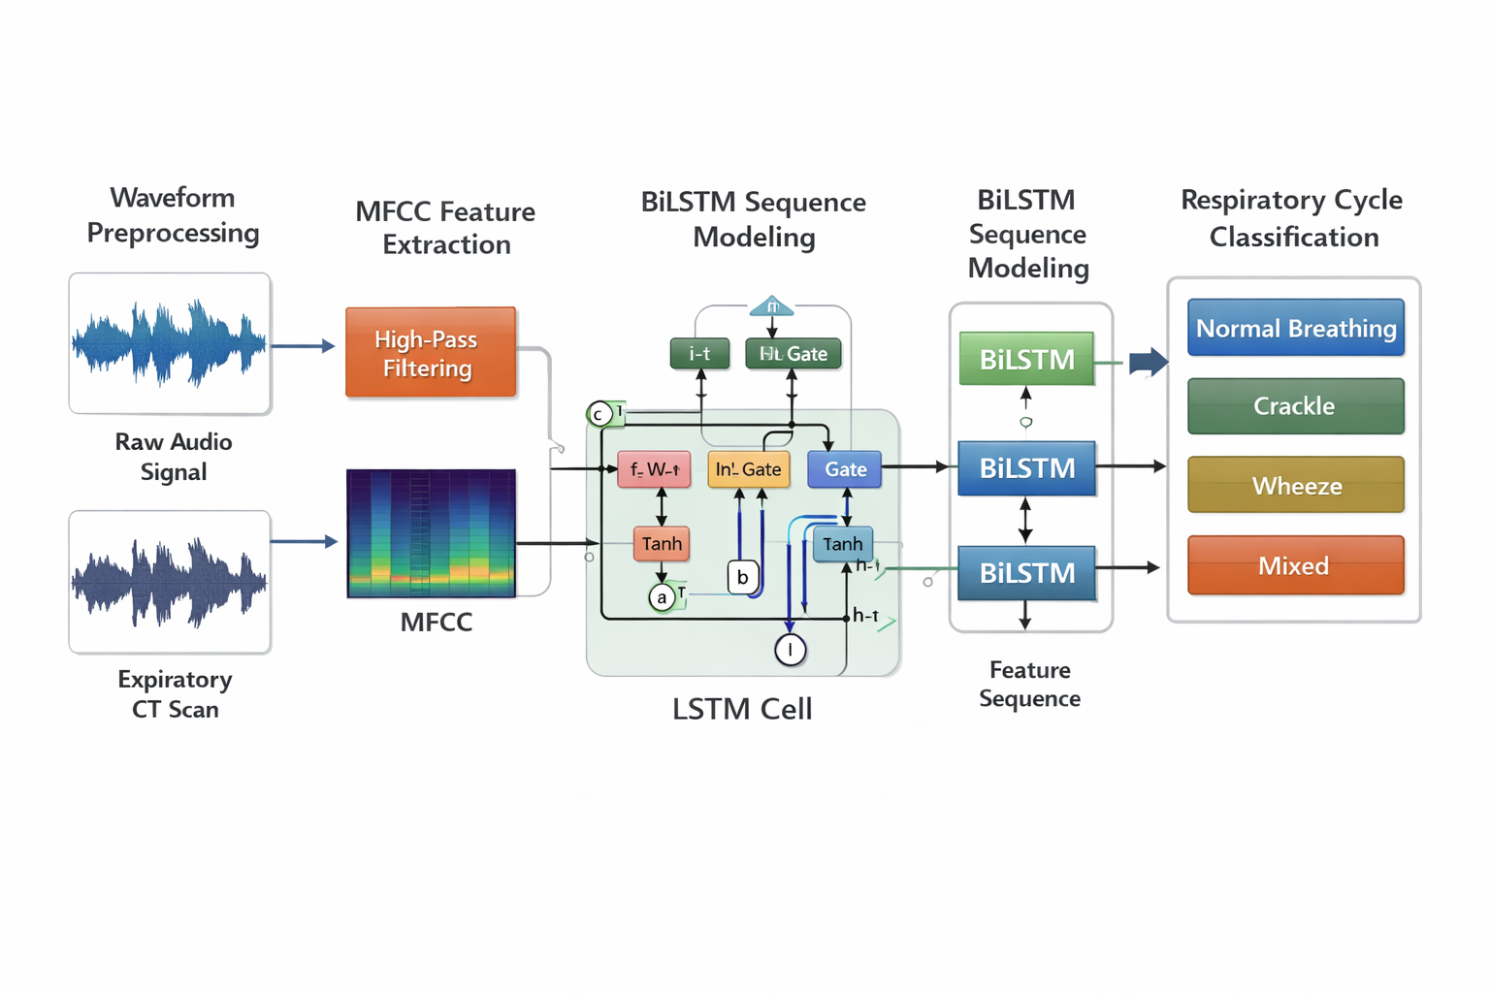Fig. 2. Authors’ original schematic of the BiLSTM-based respiratory audio classification pipeline. The forget, input, and output gates of the LSTM cell are illustrated alongside the preprocessing steps (high-pass filtering → MFCC extraction → sequence encoding → classification). (Authors’ original illustration.)

D. ICU Physiological Stream Modeling
Sequential architectures have also been applied to continuous ICU physiological streams. Vital sign measurements — SpO₂, respiratory rate, heart rate, and arterial blood gas components including pH, pCO₂, and pO₂ — are collected at irregular intervals in the ICU, creating a high-dimensional, asynchronous multivariate time series that encodes the patient's deterioration trajectory. The MIMIC-Extract pipeline standardizes this data by aligning measurements into uniform one-hour temporal buckets, computing summary statistics per interval, and producing a dense matrix ready for LSTM ingestion [8], [17]. Optimizer selection for LSTM training on clinical time-series has received specific attention: Sulaiman and colleagues found that RMSprop provided greater training stability than Adam on lung disorder prediction tasks involving irregular physiological sequences, which is consistent with RMSprop's design for non-stationary loss landscapes [21].

IV. PREDICTIVE ANALYTICS USING ELECTRONIC HEALTH RECORDS (EHR)

A. Early ML Approaches on Structured Data
The earliest computational approaches to COPD risk stratification applied classical supervised methods — support vector machines (SVMs), k-nearest neighbor (KNN) classifiers, and decision trees — to structured EHR variables and spirometric summary statistics [3]. These methods achieved clinically useful performance for basic risk stratification but ran into a fundamental ceiling: model quality was bounded by the domain expert's judgment about which variables to include, and interaction effects among variables that were not anticipated at design time remained invisible to the model. Orangi-Fard extended this approach by incorporating free-text clinical summary notes alongside structured vital signs, demonstrating that narrative documentation contains diagnostic signal absent from coded fields alone [3].
B. Random Forest and Gradient Boosting Ensembles
Ensemble methods substantially widened the performance envelope available to tabular clinical data. Random Forest (RF) — which aggregates predictions from a large collection of decision trees, each trained on a bootstrapped data subsample and restricted at each node to a random feature subset — avoids the correlated-tree failure mode of single-estimator methods and captures non-linear variable interactions without requiring explicit specification [7], [20]. The deliberate feature randomization at each internal node is what gives RF its resistance to overfitting on high-dimensional clinical datasets where many variables are weakly correlated with the outcome.
Shojaei and Delrobaei applied a semi-supervised RF classifier to a MIMIC-III cohort defined by ICD-9 COPD codes, using ten physiological and blood gas parameters routinely available on every ICU chart [8]. The classifier distinguished mild-to-moderate from severe exacerbations with 92.51% accuracy and an ROC AUC of 0.984 — with no requirement for additional investigations beyond standard monitoring. Table III shows the algorithm comparison. Gradient boosting variants, including CatBoost and AdaBoost, have achieved comparable results in other COPD cohorts, reinforcing the general advantage of ensemble strategies over individual estimators for this data type [7].

TABLE III
ML Algorithm Comparison for COPD Severity Classification on MIMIC-III [8]

Algorithm | Accuracy | ROC AUC | Precision | Recall | F1-Score
Random Forest (RF) | 92.51% | 0.984 | 0.956 | 0.906 | 0.930
SVM | 90.39% | 0.972 | — | — | —
KNN (k = 17) | 88.16% | 0.958 | — | — | —

C. Exacerbation Forecasting and Readmission Prediction
Beyond the classifications of established episodes, a growing body of work attempts to predict exacerbations before clinical deterioration becomes clear. Ahmed and his colleagues built an explainable ML model on primary care EHR data to forecast a patient's first acute exacerbation, using Shapley Additive Explanation (SHAP), values to decompose each individual prediction into its contributing variables [19]. On the other hand, Castaldi and colleagues applied several ML algorithms to the COPDGene dataset to predict five-year FEV₁ decline, finding that baseline CT features added substantial predictive value to spirometry and clinical questionnaire data [18].
A systematic review and meta-analysis by Niraula and colleagues, covering 13 published studies, found that ensemble methods and deep learning models consistently outperformed logistic regression baselines for exacerbation and readmission prediction, with a pooled AUC of 0.77 (95% CI: 0.74–0.80) across diverse patient populations [5]. Prior exacerbation frequency, blood eosinophil count, and CAT score emerged as the most consistently informative predictors across datasets — findings that align with the biological understanding of COPD exacerbation risk and provide an external validity check on the ML results.

V. THE FRONTIER: MULTIMODAL AI FRAMEWORKS

A. Clinical Rationale for Combining Data Streams
Each clinical data modality captures a different and partially non-overlapping facet of COPD. A CT scan reveals the spatial distribution and severity of parenchymal destruction in precise volumetric detail; however, it provides only an anatomical snapshot and cannot reflect dynamic gas exchange physiology. A respiratory sound recording captures the acoustic fingerprint of turbulent or obstructed airflow at a specific moment, but contains no information about the extent or smoking history. Structured EHR variables supply the biographical and clinical context — age, pack-year history, comorbidities, symptom burden — that determines the prognostic weight of imaging and acoustic findings. Combining these streams within a single learning system is therefore not a technical convenience. It’s a clinical necessity: each modality supplies information that the others lack [15], [16].
Bibliometric analyses of the AI-COPD literature have consistently identified multimodal and fusion-based architectures as one of the field's fastest-growing research directions over the past decade [6].
B. Fusion Strategies and Architecture Design
Zhao and colleagues surveyed AI architectures across the full clinical trajectory of COPD management — from early detection through exacerbation response to rehabilitation monitoring — and identified three dominant fusion strategies [15]. Early fusion concatenates raw feature vectors from all modalities before any modality-specific processing; this approach is straightforward but discards the internal representational structure that each modality's encoder learns. Late fusion trains separate models for each modality and combines their output scores; it preserves modality-specific representations but cannot learn cross-modal interactions. Intermediate fusion, which uses cross-attention mechanisms or learnable gating functions to merge intermediate-layer representations, consistently outperforms the other two strategies on heterogeneous clinical data.
Deng and colleagues proposed a multimodal deep learning system for COPD prediction that processed CT imaging, EHR variables, and clinical assessment scores through modality-specific encoders before alignment and fusion [16]. Because CT embeddings and tabular feature vectors occupy fundamentally different metric spaces, the authors applied cross-modal contrastive learning to project all modality representations onto a shared unit hypersphere, pulling same-patient embeddings from different modalities into proximity. A dynamic gating mechanism then assigned adaptive weights to each modality based on the patient's specific clinical profile, placing greater emphasis on CT in late-stage disease where structural destruction dominates and on symptom scores in early-stage disease where inflammatory burden and environmental exposure carry more prognostic weight. The complete system achieved an AUC of 0.92 with 92.3% sensitivity and 88.7% specificity for five-year disease progression prediction on a COPDGene-derived cohort, outpacing all single-modality baselines [16].

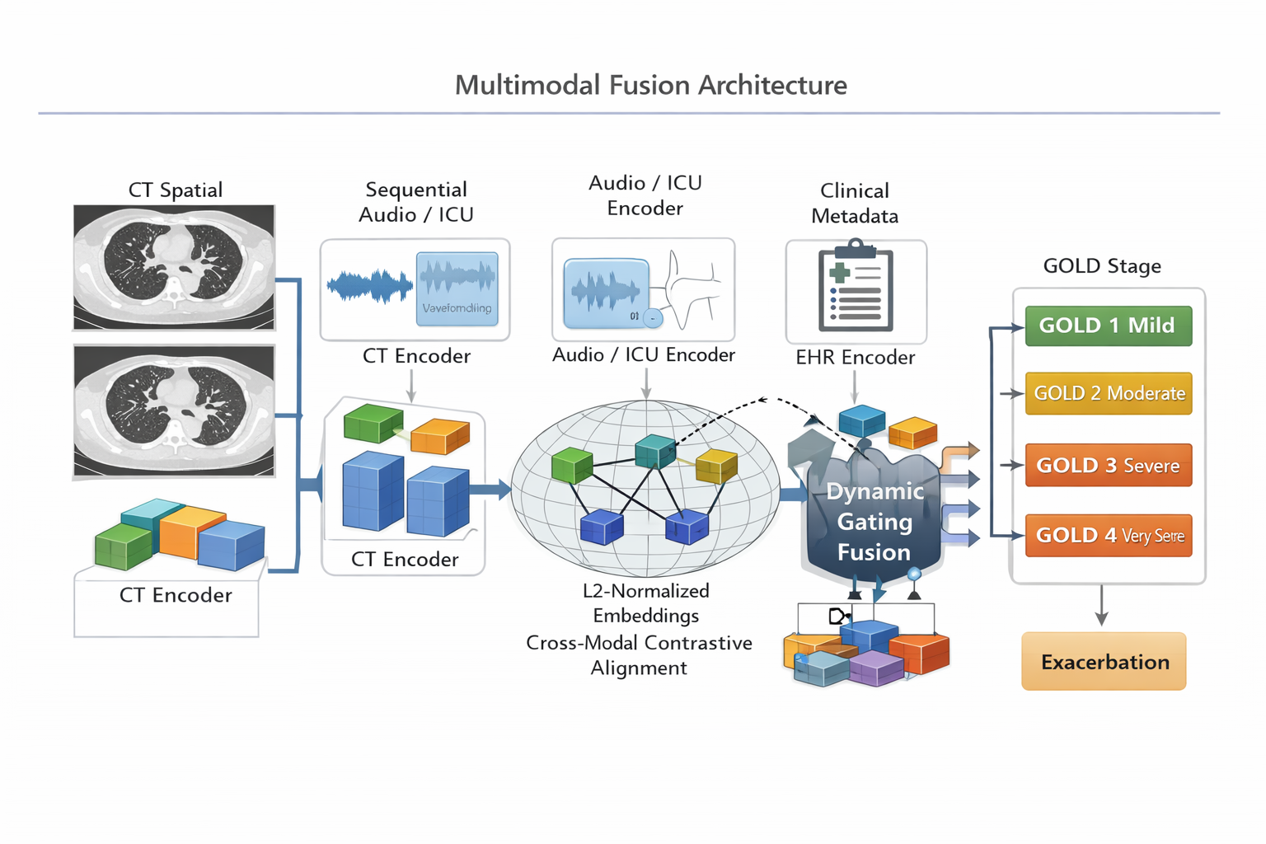
Fig. 3. Authors’ original schematic of an intermediate-fusion multimodal COPD prediction architecture. CT, audio/ICU, and EHR encoders produce L2-normalized embeddings that are aligned via contrastive learning and merged through a dynamic gating module before final classification. (Authors’ original illustration.)

C. Handling Missing Data Through Generative Imputation
A persistent obstacle to multimodal clinical AI is missing data. In retrospective EHR studies, patients routinely lack complete imaging records, laboratory values, or questionnaire responses, and the missingness pattern is typically non-random — patients with more severe disease or limited healthcare access tend to have more incomplete records. Standard mean imputation introduces systematic bias under these conditions. Several recent multimodal COPD systems have addressed this by training conditional generative adversarial networks (GANs) under the Wasserstein formulation with gradient penalty (WGAN-GP) to synthesize plausible values for missing variables, conditioned on reliably observed covariates such as age, cumulative pack-years, and available spirometry measurements [16]. Models trained on GAN-imputed datasets show substantially more robust performance as the proportion of missing data increases, compared with models trained on mean-imputed data.
D. Interpretability Mechanisms for Clinical Deployment
Strong aggregate performance metrics are necessary but not sufficient for clinical adoption. Clinicians who bear legal and professional responsibility for diagnostic decisions require some account of why a model produced a particular output before they can act on it with confidence [12]. For imaging modalities, Class Activation Maps (CAMs) and gradient-weighted saliency maps overlay the network's attention weights directly onto the CT slices used for inference [11]. In COPD-positive cases, high-attention regions consistently localize to emphysematous parenchyma and hyperinflated lung zones; in negative cases, these same regions produce low activation. Because this spatial explanation uses the familiar language of radiology — anatomy visible in the same image a radiologist would review — it can be evaluated by subspecialists without any machine learning background.
For tabular EHR modalities, SHAP attributions serve an equivalent function by decomposing each prediction into additive contributions from individual input features, ranked by magnitude [19]. The convergence of imaging-level spatial explanation with variable-level statistical attribution is emerging as a standard interpretability package for multimodal clinical AI systems undergoing regulatory review and institutional approval.

VI. CHALLENGES AND FUTURE DIRECTIONS
A. Dataset Diversity and Geographic Representativeness
The majority of high-performing COPD deep learning models have been developed and validated on a small number of large, predominantly Western cohorts — chiefly COPDGene and MIMIC-III. Both datasets over-represent White North American patients and academic medical center care patterns. A model trained on these populations cannot be assumed to generalize equitably to patients from sub-Saharan Africa, rural South and Southeast Asia, or Latin America, where biomass fuel combustion and occupational dust exposure, rather than cigarette smoking, drive the COPD burden, and where spirometric reference ranges differ from those derived from Western norms [6]. Sait and Shaikh identified demographic and geographic non-representativeness as the most frequently acknowledged limitation across the AI-COPD literature, with direct implications for the validity of reported performance estimates when applied outside training-population settings [6].
Federated learning offers a technically principled solution. By sharing model parameter updates across institutions rather than pooling raw patient records, federated frameworks enable multi-institutional, multi-national training without requiring data to leave its host institution — a key requirement given the patchwork of privacy regulations that govern health data across jurisdictions [22]. COPD-specific federated implementations remain sparse in the published literature, representing an actionable near-term research gap.
B. Model Transparency and Regulatory Readiness
The opacity of deep neural networks remains a substantive barrier to clinical adoption, separate from raw performance. A physician who cannot interrogate a model's reasoning cannot defend a decision made on its basis, and regulatory bodies in most jurisdictions require some account of model behavior before approving AI as a clinical decision support tool. The GOLD guidelines and major respiratory society statements do not yet specify validation criteria for AI-based diagnostic tools, leaving a regulatory vacuum that creates institutional risk for early adopters.
Post-hoc explainability methods such as CAM overlays and SHAP attributions partially address this gap but are approximations of network behavior rather than mechanistic accounts. Research is accordingly shifting toward inherently interpretable architectures — concept-based networks and prototype classifiers — that embed transparency into the model structure itself rather than generating explanations after training is complete [6].
C. Computational Requirements and Edge Deployment
State-of-the-art COPD models depend on GPU hardware with tens of gigabytes of video memory that is unavailable at the clinical point of care in most healthcare systems worldwide. The practical consequence is that models with proven accuracy in research settings cannot be deployed at community clinics, mobile screening units, or primary care facilities where COPD burden is often highest. Model compression techniques — knowledge distillation, structured weight pruning, and quantization-aware training — have been successfully applied to other medical imaging tasks and represent an underexplored avenue for the COPD domain [5]. Any compression pipeline must include explicit evaluation of whether accuracy losses are distributed uniformly across demographic subgroups, since performance degradations under compression have been documented across demographic subgroups in other medical AI domains.
D. The Prospective Validation Gap
Virtually all published deep learning COPD research is retrospective: models are trained and tested on datasets assembled from historical records, and they have had no influence on actual patient care. Retrospective validation establishes that a model can learn from existing data, but it cannot establish clinical utility — whether deploying the model in practice leads to better decisions and improved patient outcomes. Prospective randomized trials comparing AI-assisted to standard COPD management are needed and remain rare. Their design raises genuine methodological questions: what is the appropriate control arm, what patient outcomes constitute the primary endpoint, and how should model performance be monitored and the model updated over the course of a trial that may last several years [5]? These questions are not purely technical; they require collaboration between AI researchers, clinicians, and regulatory scientists
.
VII. CONCLUSION

This review has examined the published evidence on deep learning applications to COPD diagnosis and progression tracking across three primary data modalities. CNN-based analysis of dual-phase CT consistently achieves AUC values above 0.90 and has demonstrated superior sensitivity to longitudinal emphysema progression compared with radiologist visual scoring. LSTM-based architectures applied to respiratory audio achieve classification accuracy above 98% on the ICBHI benchmark, with the bidirectional variant providing modest additional gains through access to bilateral temporal context. Random Forest and gradient boosting ensembles applied to structured MIMIC-III ICU data reach AUC values above 0.97 for exacerbation severity classification using only parameters that are already routinely measured.
The highest-performing systems across the reviewed literature share a common architectural logic: they integrate imaging, acoustic, and tabular data through intermediate fusion strategies, use generative imputation to handle the missing-data profiles endemic to real-world EHR environments, and apply dynamic modality weighting to allocate representational emphasis according to the individual patient's disease stage. Across various independent validation cohorts, these multi-modal frameworks consistently exceed the performance of single-modality baseline models.

Four barriers must be addressed for these capabilities to translate into equitable clinical benefit. Training datasets need to be expanded to reflect the demographic and geographic diversity of the global COPD population. Model transparency must improve beyond post-hoc approximations to satisfy regulatory requirements and support genuine clinician trust. Architectures must be compressed and optimized for deployment on the computing hardware available at the point of care in lower-resource settings. And the field requires prospective randomized evidence that AI-assisted COPD management actually improves patient outcomes, not merely model performance metrics on historical data. Progress on all four fronts is achievable with deliberate, interdisciplinary effort.

REFERENCES

[1]W. Li, Y. Zhang, J. Huang, et al., “Advances in artificial intelligence applications for the management of chronic obstructive pulmonary disease,” Front. Med., vol. 12, p. 1685254, 2025.
[2]S. Bodduluri, A. Nakhmani, J. M. Reinhardt, et al., “Deep neural network analyses of spirometry for structural phenotyping of chronic obstructive pulmonary disease,” JCI Insight, vol. 5, no. 13, p. e132781, Jul. 2020.
[3]N. Orangi-Fard, “Prediction of COPD using machine learning, clinical summary notes, and vital signs,” arXiv:2408.13958 [cs.LG], Aug. 2024.
[4]C. Yin, M. Udrescu, G. Gupta, M. Cheng, A. Lihu, L. Udrescu, P. Bogdan, D. M. Mannino, and S. Mihaicuta, “Fractional dynamics foster deep learning of COPD stage prediction,” Adv. Sci., vol. 10, no. 12, p. 2203485, Apr. 2023.
[5]P. Niraula, M. Upreti, S. Kadariya, B. Poudel, S. Kadariya, and S. Kunwar, “AI/ML driven prediction of COPD exacerbations and readmissions: a systematic review and meta-analysis,” Front. Digit. Health, vol. 7, p. 1641356, 2025.
[6]A. R. W. Sait and M. A. Shaikh, “Artificial intelligence-powered chronic obstructive pulmonary disease detection techniques: a review,” Diagnostics, vol. 15, no. 20, p. 2562, 2025.
[7]W. H. Elashmawi, A. Djellal, A. Sheta, S. Surani, and S. Aljahdali, “Machine learning for enhanced COPD diagnosis: a comparative analysis of classification algorithms,” Diagnostics, vol. 14, no. 24, p. 2822, Dec. 2024.
[8]A. Shojaei and M. Delrobaei, “Severity classification of chronic obstructive pulmonary disease in intensive care units: a semi-supervised approach using MIMIC-III dataset,” arXiv:2504.18593 [eess.SP], Apr. 2025.
[9]D. A. Lynch, J. H. M. Austin, J. C. Hogg, et al., “CT-definable subtypes of chronic obstructive pulmonary disease: a statement of the Fleischner Society,” Radiology, vol. 277, no. 1, pp. 192–205, Oct. 2015.
[10]J. Chen, Z. Xu, L. Sun, et al., “Deep learning integration of chest computed tomography imaging and gene expression identifies novel aspects of COPD,” Chron. Obstr. Pulm. Dis., vol. 10, no. 4, pp. 355–368, Oct. 2023.
[11]A. S. Oh, D. Baraghoshi, D. A. Lynch, S. Y. Ash, J. D. Crapo, and S. M. Humphries, “Emphysema progression at CT by deep learning predicts functional impairment and mortality: results from the COPDGene study,” Radiology, vol. 304, no. 3, pp. 672–679, Sep. 2022.
[12]Z. Zhang, F. Wu, Y. Zhou, et al., “Detection of chronic obstructive pulmonary disease with deep learning using inspiratory and expiratory chest computed tomography and clinical information,” J. Thorac. Dis., vol. 16, no. 9, pp. 6101–6111, Sep. 2024.
[13]K. P. Exarchos, K. Stavrakakis, and P. Asvestas, “Deep learning model for early subsequent COPD exacerbation prediction,” J. Biomed. Inform., vol. 145, p. 104472, 2023.
[14]P. Zhang, A. Swaminathan, and A. A. Uddin, “Pulmonary disease detection and classification in patient respiratory audio files using long short-term memory neural networks,” Front. Med., vol. 10, p. 1269784, Nov. 2023.
[15]X. Zhao, Y. Wang, T. Li, et al., “Innovative applications and challenges of artificial intelligence in the whole-course management of chronic obstructive pulmonary disease,” Int. J. Chron. Obstruct. Pulmon. Dis., vol. 20, pp. 1097–1115, 2025. doi: 10.2147/COPD.S568919
[16]H. Deng, X. Ding, S. Zhu, X. Song, and Y. Guo, “Prediction of chronic obstructive pulmonary disease based on multimodal data and deep learning,” APL Bioeng., vol. 9, no. 4, p. 046115, Dec. 2025. doi: 10.1063/5.0289414
[17]A. E. W. Johnson, T. J. Pollard, L. Shen, et al., “MIMIC-III, a freely accessible critical care database,” Sci. Data, vol. 3, p. 160035, 2016.
[18]R. P. Castaldi, M. H. Cho, J. Bhatt, et al., “Machine learning prediction of progression in forced expiratory volume in 1 second in the COPDGene® study,” Chron. Obstr. Pulm. Dis., vol. 9, no. 3, pp. 367–377, 2022.
[19]E. Ahmed, J. Cooke, and H. Pinnock, “Explainable machine learning model for predicting first-time acute exacerbation in patients with chronic obstructive pulmonary disease,” J. Pers. Med., vol. 12, no. 2, p. 228, 2022.
[20]G. Louppe, “Understanding random forests: from theory to practice,” arXiv:1407.7502 [stat.ML], 2014.
[21]S. Sulaiman, M. N. Taib, and S. L. Salleh, “Optimization of prediction of lung disorders using LSTM: comparison of RMSprop and Adam,” J. Inform. Technol. Comput. Sci. (JITK), vol. 11, no. 3, pp. 928–936, Feb. 2026.
[22]S. Dang, N. Li, X. Chen, et al., “Design of an improved graph-based model for real-time anomaly detection in healthcare using hybrid CNN-LSTM and federated learning,” Sci. Rep., vol. 14, no. 1, 2024.

